# **Lesson 2: The Electromagnetic Spectrum and Quantized Energy**

## <H1> **Essential Question**

How does light reveal the energy levels within an atom?

# <H1> **Big Idea**

The electromagnetic spectrum includes various types of radiation, and understanding the energy-wavelength relationship is key to explaining how light interacts with matter and how electrons gain or lose energy.

# <H1> **Lesson Objectives**

By the end of the lesson, you will be able to:

Name different types of electromagnetic radiation.

Describe the relationship between the energy of light and its wavelength.

Summarize the quantum mechanical model of the atom.

# <H1> **Curiosity Corner**

Beyond the nucleus, electron movement plays a key role in interactions like how salt prevents ice formation. Think of satellites orbiting Earth – similarly, electrons orbit the nucleus. What controls their distance? Energy is the answer. Electrons shift between energy levels within the atom based on changes in energy. The electromagnetic spectrum explains how light, with its varying energy, influences these electron transitions.

# <H1> **Key Vocabulary**

Electromagnetic spectrum- Entire range of electromagnetic radiation.

Gamma rays- Highest energy waves in the electromagnetic spectrum, with the shortest wavelength and highest frequencies.

Frequency- Number of cycles or waves that pass a particular point in one second, measured in hertz (Hz)

Infrared radiation- Waves with longer wavelengths than visible light, but shorter than microwaves, felt like heat.

Microwaves- Waves with longer wavelengths than infrared radiation, but shorter than radio waves, used in communication and cooking.

Radio waves- Waves with longest wavelengths and lowest frequencies, used in communication because they can travel long distances in the atmosphere.

Ultraviolet light- Waves with shorter wavelengths than visible light, but longer than X-rays, emitted by the sun.

Visible light- Waves that are visible to the human eye, ranging from violet to red.

Wavelength- Distance between two consecutive peaks or troughs in a wave, measured in meters or nanometers.

X-rays- Waves with shorter wavelengths and higher frequencies than ultraviolet light, but longer than gamma rays, can penetrate soft tissues.

# <H1> **Ignite: How Does Light Move Through a Prism?**



You have surely seen rainbows and maybe you have even heard that they are produced because light splits. How can light split? Why are different colors produced?

# <H1> **Direct Instruction: How Are Light and Energy Related?**

In the previous lesson, you learned how electrons are arranged around the nucleus at specific energy levels, using electron configurations and quantum numbers to predict their behavior. This lesson will show how different forms of light – whether visible or invisible – interact with these electrons in everyday life and why they behave the way they do. You’ll also understand how energy relates to the light you see and use. Different types of electromagnetic radiation interact with matter, and this interaction is determined by their energy and wavelength. You’ll explore how energy can affect matter at the atomic level.

Figure 4.5. Dispersion of light

## <H2> **Progress Check 1**

Explain how the energy from microwaves interacts with food molecules to heat them.

# <H1> **Pathfinder: Understanding Visible and Invisible Light**



Figure 4.6. An experiment is demonstrated using an optical prism showing the decomposition of a light beam into a spectrum.

**Materials Required:**

prism

colored filters

flashlight

spectrum chart

**Procedure:**

1. Shine a flashlight through colored filters and note how the light changes.
2. Use the prism to split the flashlight’s beam into a rainbow. Compare this to the electromagnetic spectrum chart.
3. Discuss what kinds of light are invisible to the human eye but still part of the spectrum (e.g., infrared, ultraviolet).

**Group Discussion**: How does each type of light interact differently with matter?

# <H1> **The Electromagnetic Spectrum**

Lamps emit visible light, but this light is just one part of the electromagnetic spectrum. Different types of electromagnetic radiation, such as UV light or infrared, interact with matter in unique ways depending on their energy and wavelength. Electrons in atoms, like satellites orbiting Earth, change their positions based on these energy interactions. Understanding the electromagnetic spectrum helps explain how energy influences electron movement, guiding us in understanding phenomena like lighting and radiation.

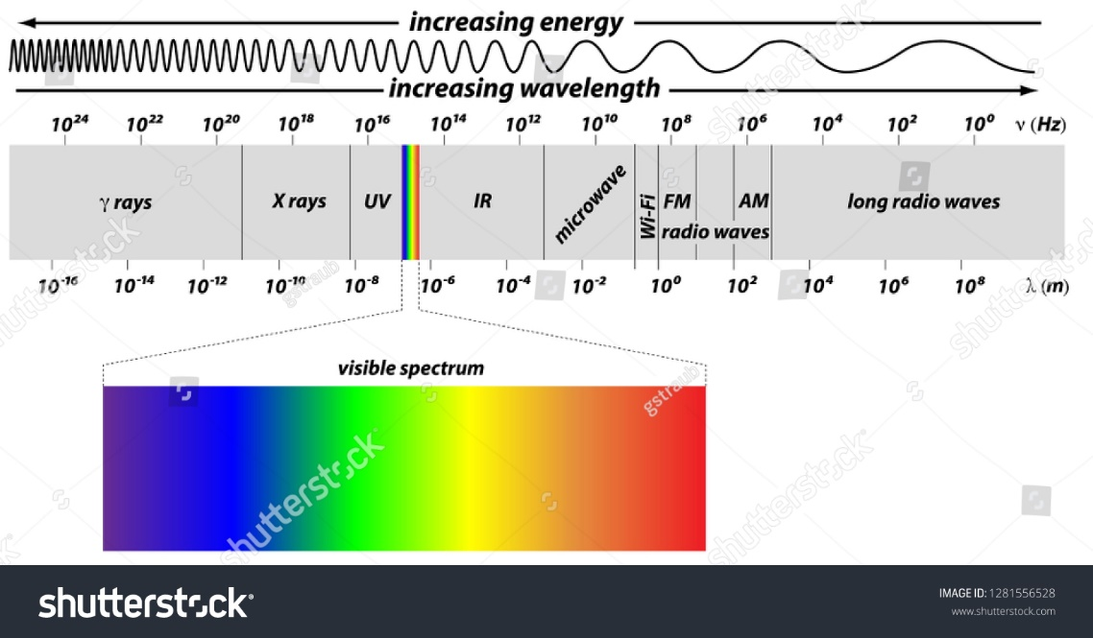

Figure 4.7. Electromagnetic spectrum.

The electromagnetic spectrum includes all types of electromagnetic radiation, ranging from radio waves to gamma rays. The arrangement of different types of electromagnetic radiation in order of their increasing wavelengths is called the electromagnetic spectrum. These types of radiation vary by wavelength, frequency, and energy. For example, **radio waves** have the longest wavelengths and lowest energy, making them ideal for broadcasting signals over long distances. **Gamma rays**, on the other hand, have extremely short wavelengths and high energy, which allows them to penetrate most materials, including dense human tissue.

Understanding where different types of radiation fall on the spectrum helps explain why microwaves are used for cooking while **X-rays** are used for medical scans.

**Solved Problem**: If gamma rays have a shorter wavelength than visible light, do they have more or less energy than visible light? Explain your answer.

Solution: Gamma rays have more energy than visible light because, on the electromagnetic spectrum, shorter wavelengths correspond to higher energy. Therefore, gamma rays can penetrate materials and are used in cancer treatments to target cells deep within the body.

<H2> **Progress Check 2**

What are some uses of electromagnetic radiation that depend on the differences in energy between radio waves and X-rays?

# <H1> **Relationship Between Energy and Wavelength**

The energy of electromagnetic radiation is directly related to its **frequency** and inversely related to its **wavelength**. The shorter the wavelength, the higher the frequency and energy. For instance, microwaves have shorter wavelengths and higher energy than radio waves, which is why they can cause water molecules in food to vibrate and produce heat, cooking the food.

$$E=\frac{hc}{λ}$$

or where $\frac{c}{λ}=ϑ$

where $ϑ$ is the frequency, *c* is the frequency of light, *λ* is the wavelength, and *h* is the Planck’s constant, which is equal to $6.626 × {10}^{-34} Js$.

When light energy interacts with matter, it can cause electrons in atoms to absorb this energy and move to higher energy levels. Therefore, you can see visible light when photons are released and why microwaves heat your food.

**Solved Problem:** Calculate the energy of a photon that has a frequency (*ϑ*) of 5.0 × 10¹⁴ Hz. Use Planck’s constant (*h* = 6.626 × 10⁻³⁴ Js).

Given:

Frequency, *ϑ* = 5.0 × 10¹⁴ Hz

Planck’s constant, *h* = 6.626 × 10⁻³⁴ Js

Formula:

*E* = *hϑ*

Calculation:





<H2> **Progress Check 3**

1. Explain why microwaves can heat food but radio waves cannot, even though both are forms of electromagnetic radiation.
2. Calculate the energy of a photon that has a frequency (*ϑ*) of **8.2 × 10¹³ Hz**. Use Planck’s constant **(*h* = 6.626 × 10⁻³⁴ Js)**.

# <H1> **Bohr Atomic Model**

In this model, electrons are particles located in defined orbitals. Electrons can jump to higher energy orbitals when they absorb energy. When they release energy, they jump down and emit light. The color of the light depends on the energy level differences between the orbitals. This is why a neon sign glows when electricity passes through it – the electrons absorb the energy, jump to a higher level, and release it as they return to a lower energy state, producing visible light. The color of the light depends on the amount of energy released.

**Solved Problem:** Explain why different elements emit different colors of light when energized.

Solution: Electrons can only occupy certain energy levels. When they absorb energy, they can jump to a higher level. As they return to their original energy level, they emit light. Different elements have different arrangements of electrons, leading to different energy changes and, consequently, different colors of light. For example, when sodium is energized, it emits a bright yellow light, while strontium produces a red light.

### <H2> **Progress Check 4**

A gas emits a bright blue light when it is energized. Explain why this occurs and what it tells about the energy levels of the electrons in the gas.

# <H1> **Stability of Electromagnetic Interactions**

Different types of radiation interact with matter in unique ways, depending on their energy and wavelength. For example, **infrared radiation** can be felt as heat because it causes molecules to vibrate, while X-rays can pass through the body, creating images of bones. Understanding these interactions allows scientists to design technologies that harness specific parts of the spectrum for useful purposes.

**Solved Problem**: Why are X-rays used in medical imaging instead of microwaves or visible light?

Solution: X-rays have enough energy to pass through soft tissues but are absorbed by denser materials like bone, allowing doctors to see inside the body. Microwaves and visible light do not have the energy to penetrate the body in this way, making them unsuitable for medical imaging.

<H2> **Progress Check 5**

Explain how the differences in wavelength and energy make radio waves useful for broadcasting.

# <H1> **Quantum Mechanical Model of the Atom**

The quantum mechanical model is a probabilistic model. Rather than claim that the electron is in a certain defined orbital, the quantum mechanical model describes the probability of finding an electron in a given region of space around the nucleus. The quantum model sees electrons are waves rather than particles.

## <H1>**Power Up**

The Questionnaire Icon

Reflect on the following prompts to think critically about the content and come up with meaningful questions for inquiry about **The Electromagnetic Spectrum and Quantized Energy**:

1. Different types of electromagnetic radiation have varying wavelengths and energies.
2. The energy of light determines how it interacts with matter.
3. Electrons absorb and release energy when they move between different energy levels.
4. Understanding the electromagnetic spectrum helps explain the practical uses of different types of radiation.

## <H1> **Lesson Check**

1. Describe how different types of electromagnetic radiation vary in their energy and wavelength. Use examples from the spectrum, such as radio waves and gamma rays, to explain your answer.
2. Explain why X-rays are suitable for medical imaging, while microwaves are used for heating food, even though both are forms of electromagnetic radiation. How does the energy and frequency of each type contribute to their specific uses?
3. Electrons can shift between energy levels based on the energy they absorb or release, similar to how satellites adjust their orbits. How does this concept help explain why different types of electromagnetic radiation, like ultraviolet or infrared, interact differently with atoms?
4. A neon sign emits visible light when electricity passes through it. Based on the quantum mechanical model, explain why this happens and how it connects to the movement of electrons within the atom.
5. Different forms of electromagnetic radiation can interact with matter in specific ways. Explain how ultraviolet light can cause sunburns, while infrared light is felt as heat. What makes their interactions with matter different?
6. Relate the process of electrons absorbing and releasing energy to how salt helps melt ice on roads. How do these two different processes demonstrate the effects of energy interactions?
7. Which of the following best explains why X-rays can pass through soft tissue but are absorbed by bones?

A. X-rays have longer wavelengths than visible light.

B. X-rays have higher energy, which allows them to penetrate soft tissues.

C. X-rays can be easily reflected by bones.

D. X-rays have lower frequency, making them more powerful.

1. Why do elements emit different colors of light when they are energized?

A. Each element absorbs the same amount of energy.

B. The electrons of each element can only move to one energy level.

C. Each element has a unique arrangement of electrons that causes them to emit different energy levels as light.

D. The atomic nucleus controls the color of light emitted.

## <H1> **Beyond the Lesson**

The electromagnetic spectrum has countless applications in technology and healthcare. Infrared cameras help detect heat, radio waves enable communication over long distances, and X-rays allow doctors to see inside the body without invasive surgery. Learning how different wavelengths of light carry different amounts of energy enables scientists to design everything from solar panels to MRI machines, creating solutions that improve everyday life and safety.